City Semester 13-14 Ms. Nelson

PROBLEM SET 1-3: Measures of Center

"Get your facts first, and then you can distort them as much as you please.” - Mark Twain

-  New York City Public Schools are required to publish data on test scores for a number of state or nation-wide tests. The file “NYC-SAT-Specialized-HS” contains data on average SAT scores for the class of 2012 from twelve specialized high schools.
  - Analyze the data based on the factors we’ve discussed thus far.
  - As the principal of the High School for Public Service, write a sentence or two that convinces your school that the seniors did really well on the AvgCritReas portion of the test, using statistical measures as well as the distribution you see.
  - Now write as if you are the superintendent and trying to convince the principal that they didn’t do so well after all and need to improve (again, using statistical measures as well as the distribution you see).

- Make up a data set of five data values in which the mode is negative and is positive.

- Make up a data set of ten data values in which is negative and the median is positive.

-  The Mets and Yankees had vastly different payrolls for 2013. Both teams salaries, along with the total payroll for all MLB teams is in the file “MLB Salaries”
  - What is the mean salary of the Mets? Yankees?
  - What is the median salary of the Mets? Yankees?
  - If you read a newspaper story about the Mets the mean as a measure of center, what type of “spin” would the writer be trying to use?
  - If you read a newspaper story about the Mets that used the median as a measure of center, what type of “spin” would the writer be trying to use?
  - Look at the distribution of all teams’ payrolls – summarize what you see

- Google “New York City mean household income”. What kind of links are you getting? (Read not only the title of the page, but also the short excerpts under the link.) Why do you think this is happening?

- Summarize for what type of distribution is mean the most appropriate measure of center, and which for median, and which for mode.

Many problems courtesy of Nils Ahbel – used with permission

Pre-Calculus:FST Ms. Nelson

PROBLEM SET 1-5: Standard Deviation and Z-scores

"When standard deviations change we should be very concerned – it’s a sign of global weirding”
(referring to environmental stats) -Nils Ahbel

-  Open the Fathom data set called “Motor Vehicles” and “Analyze the Data”.

The z-score tells us how many standard deviations above or below the mean a data value lies. A positive z-score tells how many standard deviations above the mean a value lies. A negative z-score tells how many standard deviations below the mean a value lies. The z-score is given by the equation 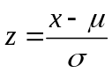, where x is a member of the data set, is the population mean and σ is the population standard deviation. So if you get a 90 on a test for which is 80 and σ is 10 then your z-score is 1 – you got a score which was 1 standard deviation above the mean. If you get a 65 on the same test then your z-score is -1.5 – you got a score which was 1.5 standard deviations below the mean.

-  Refer to the Fathom data set for Motor Vehicles:
  - What is the z-score for Wyoming? What does that z-score mean?
  - What state got the lowest z-score? Write a complete sentence describing what that z-score means in the context of motor vehicles.
  - What is true about all states that have negative z-scores?

We will be using Excel extensively in this class. It requires a little set-up. These instructions are for Excel 2007 – do a little Googling if you have another version.

Before you can use Excel to run the Excel Spreadsheet to Practice Mean and Standard Deviation, you will need to open Excel 2007 → Office Button → Excel options → Manage: Excel Add-ins → Go → Add-ins…→ ☑ Analysis ToolPak and ☑ Analysis ToolPak – VBA → OK
Also, you will need to change the security setting so that the macros run. If you are getting a message that Macros will not run, open Excel 2007 → Office Button → Excel options → Trust Center → Trust Center Settings → Enable all macros.

- Open the Excel workbook “Estimate Mean and Standard Deviation”. Practice estimating the mean and standard deviation of a data set until you can estimate the mean to within about 5 units and the standard deviation to within about 2. Press the button “Create new data” to repeat the process.
-  You are taking Physics and you just took your 1st test. The scores of everyone in the class are 81, 80, 80, 81, 81, 82, 80, 81, 82, 80, 80, 81. (The data set is called “Physics Test 1”.)
  - Was this a fair test? Why or why not?
  - Your friend in the class is bummed because he got an 80. What would you tell him?
-  The scores on the 2nd test were 79, 79, 85, 79, 89, 87, 94, 97, 72, 74, 79, 79. You got a 79. Write a short paragraph on how you did. (The data set is called “Physics Test 2”.)
-  Three people got an 88% on a test, one in period 3, one in period 5, and one in period 7. The scores of all the students in the three classes are shown below. Did they all do the same relative to their classmates? Who did the best? Who did the worst? Explain. (The data set is called “Test Scores-Periods 3,5,7”.)
Period 3: 90, 77, 77, 83, 79, 77, 92, 84, 83, 83, 88
Period 5: 88, 62, 75, 83, 78, 74, 96, 84, 83, 94, 96
Period 7: 82, 82, 82, 82, 82, 83, 83, 83, 83, 83, 88
Many problems courtesy of Nils Ahbel – used with permission
Pre-Calculus:FST Ms. Nelson

PROBLEM SET 1-6: Histograms

"It is a capital mistake to theorize before one has data”
-Sir Arthur Conan Doyle

“If you don’t read the newspaper you are uninformed, if you do read the newspaper you are misinformed.”
-Mark Twain

Many problems courtesy of Nils Ahbel – used with permission
Pre-Calculus:FST Ms. Nelson

PROBLEM SET 1-7: Histograms

“Statistics show that of those who contract the habit of eating, very few survive.”
-George Bernard Shaw

- Fill in the following table with Yes, No, NA (Not Applicable), and comments as appropriate.
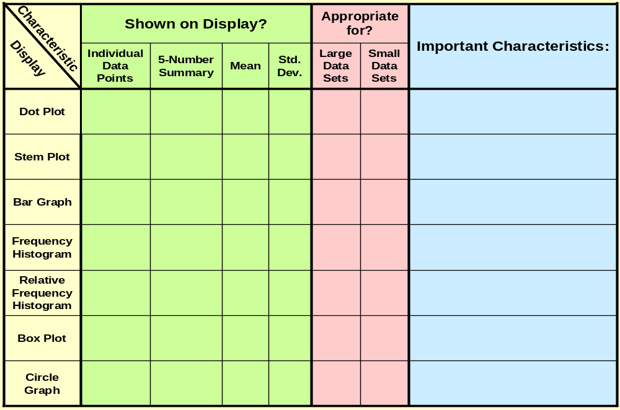

- Which display(s) would not be appropriate for the set of heights of all students at Riverdale Country School? Explain why. Which display(s) would be appropriate?
- Which display(s) would not be appropriate for the set of ages of students in this class? Explain why. Which display(s) would be appropriate?

Many problems courtesy of Nils Ahbel – used with permission
Pre-Calculus:FST Ms. Nelson

“SPIN THE DATA” PROJECT

“I can prove anything by statistics except the truth.” - George Canning

 The New England Journal of Medicine published an article (354;15, P. 1651) in April of 2006 which included, among other things, information about trans fat in french fries for many cities around the world. The article has a table which contains "a comparison of the amounts of industrially produced trans fatty acids in a large serving" of french fries from McDonalds and KFC. The values in the table are trans fatty acids as a percent of the total fat. According to information provided in the article, “daily intake of about 5 g of trans fat is associated with a 25% increase in the risk of ischemic heart disease. For this reason, it is recommended that the consumption of trans fat be as low as possible”.

The data published in the New England Journal of Medicine published are found in a Fathom file posted on Moodle in Unit 1 under “Spin the Data Project”

You will write two position papers using that data as support. The first article will be written with a spin that makes McDonalds french fries look healthier than KFC french fries. The second article will be written with a spin that makes KFC french fries look healthier than McDonalds french fries. You may assume an audience that is familiar with basic statistics.

The report for each fast food chain should be a concise, 1-2 page document that includes at least two (no more than three) sophisticated arguments convincing your audience of why the french fries from that chain are healthier. Each argument should have a visual display with explanatory captions (screenshots may be taken from Fathom) and should use color for emphasis/organization, not decoration. Different types of displays should be used for the different arguments within one position paper. Underneath the display should be a short paragraph that explains the argument in persuasive (though not perjurious) prose.

Each argument should contain a fact, a comparison and an analysis/conclusion. More sophisticated arguments will be given more credit. No credit will be given for an argument solely comparing means or medians. The value of the assignment is in the creation of persuasive, novel arguments, not in lengthy prose or fancy presentations.

We will work on this project in class over the course of a few days – you are expected to work on the timeline set out in class.
(over)

To sum up:

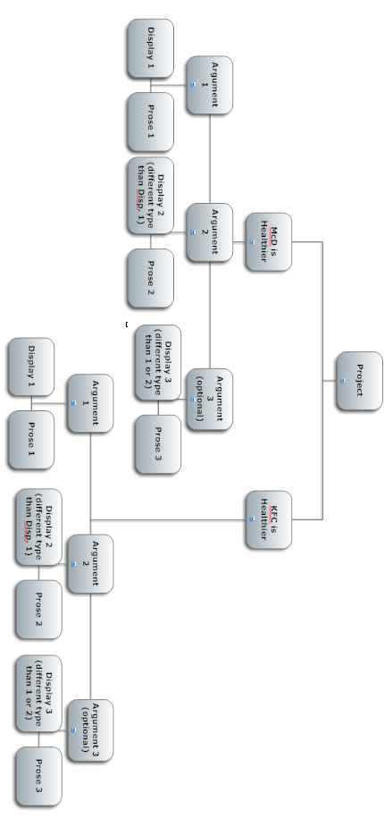
Pre-Calculus:FST Ms. Nelson

FEDERALIST PAPERS ACTIVITY

“Democracy is an abuse of statistics.” - Jorge Luis Borges

 This is a statistics lab about The Federalist Papers, which were written between 1787 and 1788 to persuade the citizens of the State of New York to ratify the Constitution.

Stylometry is used to infer who wrote the disputed Federalist Papers. Each student is assigned 5 papers at a time. The steps are:

- Open up the paper in Word
- Calculate the number of occurrences of the word “by” in the paper by using the Word feature called Edit → Replace. Find what: “ by “ and Replace With “ ** “. (Note a space before and after.) Word gives the number of times “ by “ was replaced, a way of counting the number of occurrences of the word “by”.
- Use Tools → Word Count to count the number of words in the document.
- The quotient of (2) and (3) multiplied by 1000 gives “by”s per 1000 words.

The idea for this lesson comes from FST 2nd edition, UCSMP, Usiskin et all, Scott Foresman, Chapter 1.

